**Department of Computer Science**

**Forman Christian College University**

**COMP360: Introduction to AI**

**Spring 2024**

**Lab 4**



|  |  |  |
| --- | --- | --- |
| **Task 1**  **(10 Marks)** | **Task 2**  **(10 Marks)** | **Total**  **(20 Marks)** |
|  |  |  |

**A* Search**

**Lab Instructions:**

* Get your attendance marked before leaving the classroom.
* This is an individual Lab assignment. Each student must submit their own work.
* IMPORTANT: Run the name_Roll_lab3.py file and make sure it runs without any errors.
* Then populate the below mentioned files with your implementation.
* After you’re done with your implementation, change the python file “lab#_name_roll.py” and replace your “name” and “roll_no”.
* Finally zip the files and upload them on tmoodle.

**Task 1:**

Modify graph.py to have the ability to store heuristics. Fill out the function 'get_h' in graph.py to get heuristic for a node: input will be a Node and output will be heuristic. Create the following graph in graph.py and check all its methods.

Find the path to reach from **S** to **G** using **A\*** search.

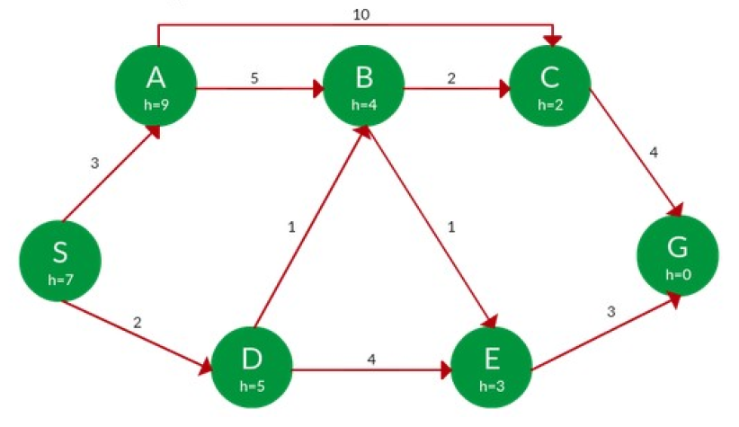

**Task 2:**

Use this updated graph class to represent the above graph and find the shortest path and its cost from S to G by implementing A*.